Shabbos Stories for
Parshas shemos 5780
Volume 11, Issue 19 21 Teveth/ January 18, 2020
Printed L’illuy nishmas Nechama bas R’ Noach, a”h

For a free subscription, please forward your request to keren18@juno.com

Ven Me'haist Tanzin…
By Tova Younger

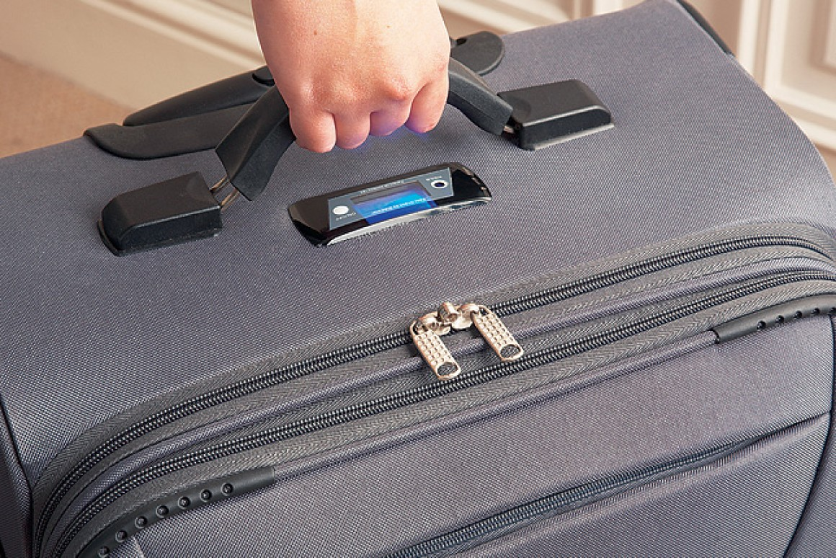

When it is bashert for us to dance… That is from a story I grew up with, having heard it many times from my survivor parents. It popped into my mind on a recent excursion we took, a simple trip from Kiryat Sefer to Neve Yaakov.
Kiryat Sefer, home to about 8,000 families, enjoys very convenient bus service. Daily there are a few buses every hour to Bnai Brak and Yerushalayim, with a few buses to other less traveled destinations. For Shabbos, there are additional buses to quite a few more places, making it quicker, cheaper and more pleasant to go away for Shabbos.
Travelers Must Go to An Area Called “Masof”
Unfortunately, some of these special busses do not make pickups throughout the city; rather travelers must go to an area called 'masof' where they can board the bus. Getting there is not always so easy, since many are traveling with suitcases and strollers.
On this particular trip, we – I was traveling with my husband and two teens – were heading to Neve Yaakov with 3 large suitcases. I decided on the spur of the moment to splurge on a taxi to take us to the masof. Although the taxi only costs about $6 (a taxi to Neve Yaakov would cost about $50), we do usually walk.
This time, as it was hot, and we were dressed in our Shabbos clothes, and had more luggage than usual, I thought it was a time to spend. We enjoyed a quick ride to the masof, got on the bus and enjoyed a quick ride – under an hour. It passes so pleasantly, we were not really paying attention to the fact that we had arrived. And all of a sudden, the bus was lumbering on, past our stop! Down a long hill! We have traveled to Neve Yaakov many times, but this was a first! To miss our stop!

Exited the Bus and Forced
To Climb Uphill in the Sun
We pushed the button, belatedly… there was nothing to be done. We exited and began the climb uphill in the sun, dragging along our three suitcases. To my family's credit, no one complained or blamed. When I wondered aloud what had happened, there was no response. Everyone simply walked along, offering to trade off the heavier suitcase, and within a few minutes we arrived at our destination. The thought that came to my mind was: ven me'haist shleppen…
The original story is well worth repeating, packed as it is with a view of the past and an appreciation of our current situation vis-à-vis goyim; it is also a great hashgachah pratis insight.
In Europe of days gone by, inns were common scenes of stories. In this one, two Yidden had been traveling all day and needed a place to sleep. They did not require more than a couple of mattresses – luckily, as that is probably all they got. Inns were not known for comfort and amenities.

The Only Entertainment Consisted of Bothering the Yidden
Shortly after they came, along came a few goyim, who enjoyed some food and drinks. And then? Remember that entertainment in those days was extremely limited, actually almost non-existent. The only entertainment consisted of bothering people, and Yidden were a favorite target. One goy asked the owner, "Any Jews here? We are bored, we need some action!"
"Sure – in that room there, you have two, they came and went straight to sleep."
One goy got up. "I'll go get one. Let him dance for us! That will be fun!" Quick as he could in his drunken state, he brought one of the Yidden to the dining area. "Dance, Jew! Dance!"
That poor fellow, although so rudely awoken from his sleep, knew he had no choice. If he did not comply, he could get beaten or worse. So he danced. Five minutes, ten. Presumably the goyim were duly entertained, until they got bored of that as well, and the Yid was able to return to his sleep.
More time passed; more wine, more senseless talk… "Let's get that Jew again. He was really good for a laugh!" The goy went and brought out the Yid, and the performance was repeated. This time when the Yid returned to his room, he woke up his companion. "My dear friend, do me a favor! I'm not getting any sleep! Those goyim came and dragged me out two times to dance for them! They might come again, so do me a favor and let's switch places. Take a turn, please!"

When it is Bashert to Dance
A true ba'al middos, he agreed. And surely enough, an hour later the goy came and again threw open the door, and reached out… but in his drunkenness, he had a thought. "Ahh, we had this Jew twice already. Let's see what the other fellow can do!" And our unfortunate Yid had to dance yet a third time… When it is bashert to dance…
If we must dance, we will dance. If we must shlepp, we will shlepp.
Should we not do what we can to make our lives go smoother? Was I wrong to summon a taxi? Certainly we can and we must make hishtadlus as needed. Rabbi Avigdor Miller says, "Hashem sent you a headache? He also sent you aspirin!" But let's never forget where it all comes from and when our hishtadlus is not successful, let's thank Him for our yissurim, without blaming or complaining, while davening that they not be more severe...
(According to some, the Yidden in this story are the well-known brothers, early Chassidish Rebbes, Reb Zusha and his brother Reb Elimelech.)

Reprinted from The Jewish Press.

More Inspirational Stories
Of the Sdei Chemed

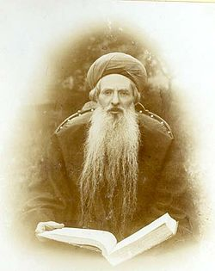

After he settled in Chevron, R’ Chaim Chizkiyah (the Sdei Chemed) established a yeshivah. The cream of Bnei Yeshivah gathered around R’ Chaim Chizkiyah to hear his daily shiur. Laymen were also privileged to drink from his wellspring of Torah during his daily shiur in Yalkut Me’am Loez.
Once a great Torah scholar visited Chevron and, of course, wished to pay a visit to R’ Chaim Chizkiyah. He anticipated having a deep and intricate Torah discussion with this worldrenowned Gaon and Poseik. How surprised he was to find him in the Beis Medrash with butchers, shoemakers and barbers, teaching simple midrashim from the Yalkut Me’am Loez.

Able to Descent from His Lofty Level in Order to Help Others
When the visitor asked R’ Chaim Chizkiyah if perhaps it was not more fitting to his honored status to give a deep shiur in Gemara and Poskim, R’ Chaim Chizkiyah answered pleasantly, “If I will give up this shiur, the participants will give up their learning and will not taste the sweetness of Torah at all. The more effort I invest in teaching them even simple midrashim, the more they will benefit from their learning.” This was but one of R’ Chaim Chizkiyah’s strengths – he was able to descend from his lofty level to provide for the needs of all his beloved congregants.
Chevron was not immune to the foreign winds of the “haskalah” (enlightenment), threatening at that time to ensnare yeshivah students in its net. R’ Chaim Chizkiyah kept a watchful eye on each of his students, speaking with them frequently and assuring that they remained free of any foreign influences.
He once took notice of a young boy, the son of a Chazzan, who accompanied his father in singing the special pesukim sung at a Bris Milah (according to Sephardic custom). R’ Chaim Chizkiyah sensed that this talented, bright boy might easily fall prey to the haskalah.

Asked the Boy to Write Out the Lyrics for One Bishlik
After the Bris, he asked the boy if he would please write out the lyrics of the songs in exchange for one bishlik (equal to the full day’s wage of a worker). Excitedly the boy agreed and later that night presented R’ Chaim Chizkiyah with neatly written pages of the lyrics.
After complimenting him on his penmanship and accuracy, R’ Chaim Chizkiyah asked if he could re-write the lyrics in a larger handwriting, as R’ Chaim Chizkiyah’s eyesight was weak – and he would be paid another bishlik!
The boy readily agreed, and by the time he finished, a strong bond of love had formed between the aged sage and the young boy. That had been R’ Chaim Chizkiyah’s sole intention all along, as now he was easily able to convince the boy to first join his Shabbos shiur, and then the yeshivah. This boy grew up to become a very diligent and outstanding student.

Advice for the Poor Widow
A poor widow in Chevron finally managed to find a suitable young man for her daughter. When she came to invite R’ Chaim Chizkiyah to the engagement meal, he wished her well and told her with great sensitivity, “Certainly many people will want to participate in your simcha. Your daughter is renowned as a modest, G-d-fearing girl and the chosson is a Torah scholar. There would not be enough room in your home, so we will celebrate the simcha here in my home. All you have to do is to come – we will take care of everything.”
When people heard where the simcha was to be held, they converged on the Rav’s house, whereas they would never have gone to the simcha in the hovel that was home to the poor widow. The crowds of well-wishers and the lively singing uplifted the hearts of the poor widow and her daughter. The people of Chevron said that whoever did not participate in that simcha never experienced true simcha. (Baal HaSdei Chemed)

Reprinted from the Parshas Vayechi 5780 email of The Weekly Vort.
The Man with Those
Sparkling Blue Eyes
By Rabbi David Ashear

Rabbi Pesach Krohn told a story about Rabbi Akiva Senderovitz, who was waiting one night in his home for a young man named Avraham to come meet his daughter of marriageable age. The bell rang, he opened the door, and welcomed Avraham in. The first thing he noticed was Avraham's deep-set, sparkling blue eyes. The Rabbi immediately recalled the last time that he saw such eyes, and tried to find out if this was the same person. He asked the young man some questions, and was astonished to realize who was standing in front of him.
The Rabbi's mind was thrust back 21 years when he was in Poland in 1939. He and his wife were about to board a boat to America, when they heard a young girl screaming and pleading with the officials at the boarding gate. There was a woman there with her nine-year old daughter and her infant, trying to board. She had a visa, her infant did not need one, but she did not have one for her nine-year-old. The officials would not let her on the boat.
With a tremendous amount of self-sacrifice, Akiva went and gave the girl his papers. He told his wife that he would find another way of getting to America, and she acquiesced. The woman could not thank them enough for their super-human kindness.
Months later, Akiva did board another boat that was actually leaving from Russia on the way to Japan. On the boat was a respected Dayan(Judge), Rabbi Meyer Lieberman, with his wife and their young son, Avraham. Within the first 24 hours of the voyage, they became severely sea sick, and had to remain in their cabin for days.
They needed someone to care for their little Avraham, and Akiva who was traveling alone, offered his services. He took care of that boy during the entire voyage as if he was his own son. He prayed with him, he learned with him and he played with him. His deep blue, piercing eyes stood out- eyes that Akiva would never forget.
After the boat docked, the Liebermans thanked Akiva profusely and they went their separate ways. Akiva made his way to New York to meet his wife, and the Leibermans settled on the west coast. Years later they sent their son, Avraham, to Yeshiva in Brooklyn, and then, as Hashgacha would have it, he was suggested for Akiva's daughter. A few months later, they were married.
Akiva spent weeks taking care of little Avraham, treating him like he would his own son. Little did he know that he was actually taking care of the boy who would eventually come back to spend the rest of his life taking care of his daughter.
Hashem remembers everything and is constantly orchestrating situations in which people's good deeds come back years later to benefit them.

Reprinted from the January 20, 2017 email of Daily Emunah.

An Unforgettable Shabbos
In Antwerp, Belgium

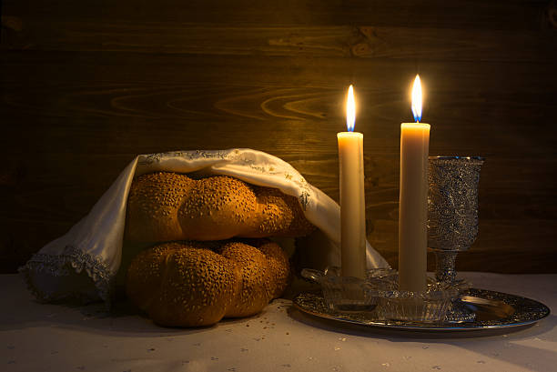

In the large city of Antwerp, Belgium, there lived a Jewish man, who unfortunately turned away from the path of Torah and Mitzvos, and he did not keep Shabbos. As time went on, he felt feelings of remorse, and he began to keep Mitzvos. Slowly, he returned with complete Teshuvah, and though it was difficult for him, he accepted upon himself to keep Shabbos with its proper sanctity.
This man had a busy store in the center of the shopping district. Once he returned to keeping Shabbos, he became accustomed to close his store early on Friday afternoons. He would announce in the store that the shoppers should make their final purchases, as the store was closing. Then he would close the store, pull the gates, and go prepare himself for the coming Shabbos Queen.
Over the course of Shabbos, he would keep busy learning Torah and other holy matters. A short while after he began to keep Shabbos, the gentile ‘holiday season’ approached. During this time many people did their shopping for the holiday. That year, the holiday was on a Sunday, and many non-Jewish, last minute shoppers, rushed to the stores to make their purchases. This was a very profitable time of year for the storekeepers, as they would do a lot of business.
Naturally, that year the majority of purchases were being made on the Friday and Shabbos before the holiday, and it was a great challenge for this Baal Teshuvah, as his store was in the center of the busy shopping area, which was filled with many shoppers, and his business benefited from all the shoppers and the many purchases that they made.
Still, he stood firm by the commitment he took upon himself, and on Friday afternoon, as the time he designated to close early for Shabbos approached, when the store was busy and filled with customers, he announced that everyone should make their final purchases, as the store was closing.
That evening, as he was going home from Shul after Davening, he noticed all the non-Jews walking about with their arms full of shopping bags and their many purchases, and his heart tightened within him. He saw all the other stores open for business, and busy with crowds of customers, and he was pained by the large loss of income that he could have made on this Shabbos.
On his way he met one of his former friends who taunted him, “What’s wrong with you?! You closed your store on a day like this?! You are ruining your business! People will get accustomed to shop by your competition!” When he began to explain that he started to keep Shabbos, his friend laughed at him and mocked him, and said, “And what will happen if you keep one less Shabbos a year?”
The man came home with a heavy and bitter heart, and he told his wife that it was very difficult for him to withstand this challenge and always battle his Yeitzer Hara. He told her, “I have therefore decided that at the Shabbos Seudah, I will drink several cups of strong vodka, which will put me in a deep sleep for many hours. This is how I will spend most of Shabbos, and the Yeitzer Hara will not be victorious in this difficult challenge!”
He drank until he fell into a deep slumber. The next morning, his wife, as per his request, did not wake him for Davening, and he continued to sleep until late afternoon on Shabbos. He awoke towards the evening, without any Tefilah, reading from the Torah, or going to Shul, and with difficulty, he managed to go to Shul for Minchah.
After Shabbos, when the man thought about how he spent Shabbos in a deep sleep, without Davening or learning, with only complete emptiness, his heart broke within him. Is this how to spend Shabbos Kodesh? There is nothing more despicable than this! He was very upset with himself, and in his great anguish and pain, he went to visit the Rav. Perhaps he would have a way to correct the Aveirah of desecrating the honor of Shabbos.

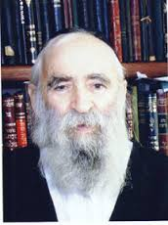
Rav Chaim Kreiswirth, zt”l

The Rav of the city at that time was the Tzadik, Rav Chaim Kreiswirth, zt”l. When the man came into the Rav’s house, the atmosphere of Shabbos Kodesh still permeated the house. The Rav had just returned from Shul, shining and glowing from the sanctity of Shabbos, many holy Seforim that he had learned over Shabbos were still out on his desk, and the silver that was used on the holy day was still out. At the sight of all this, his heart tightened greatly within him. He thought to himself how his own Shabbos was so distant from this Kedushah! The Rav greeted him warmly, and he asked the man what was bothering him.
The man began to cry, and with a pain-filled heart he told the Rav, “I am so jealous of your Shabbos! Here was a Shabbos filled with Torah, filled with Kedushah! How much joy and satisfaction there is for Hashem from your Shabbos Kodesh! But as for me, I spent the entire Shabbos in bed. No Torah, no Tefilah, no learning, and no Zemiros. It was a Shabbos filled with sleep and emptiness. How my heart is filled with jealousy for your Shabbos!”
The man cried and tears streamed from his eyes. When his crying subsided, the Rav asked him why he had slept so much, and the man explained why he did what he did.
When Rav Chaim heard this, his eyes lit up, and to the man’s utter amazement, the Rav requested of him, “Please, I very much want to make an exchange with you! Let’s exchange our Shabbosos. You take my Shabbos and give me your Shabbos. If you would only agree to this exchange with me! Your Shabbos is so much greater than mine! How you overpowered and withstood the challenge and difficulty of the Yetzer Hara this Shabbos, is worth beyond measure! It shines and illuminates in all the worlds! As Chazal teach us in Masechta Avos (5:22), according to the effort, so is the reward!”
The man then understood what had happened. That Hashem had specifically sent him this difficult challenge just when he had started keeping Shabbos, to help him stay committed, to save him, to strengthen his Yiddishkeit, and his Shabbos Kodesh. The man became happy with his Shabbos and did not exchange it. He returned home happy after learning and appreciating the value of one Jewish person’s service to Hashem!

Reprinted from the Parshas Vayeishev 5780 email of Torah U’Tefilah: A Collection of Inspiring Insights as compiled by Rabbi Yehuda Winzelberg.

Story #1152
Seventy-Fours
From the desk of Yerachmiel Tilles
editor@ascentofsafed.com

Towards the end of his life, in 1850, Rebbe Moshe of Lelov traveled to the Holy Land, arriving shortly after the Sukkot festival that year. He said that if he prays at the Kotel HaMaravi (Western Wall) [and blows the shofar there], it will hasten the Ingathering of the Exiles and the Coming of Moshiach.
Before he began his journey, he went to take leave from several of the major Chasidic leaders of his generation. When he came to Rebbe Yisrael of Ruzhin, the Rebbe said, "Wait for me. I want to go with you."
R. Moshe pointed to his white beard, implying that he was getting older and didn’t have time to wait.
His plan was to travel with a group of ten people. He put away money for this cause, but whenever he had enough money he ended up giving it to tzedakah, and then he would have to start saving money for the trip again.
Once, a childless woman came to Rebbe Moshe, and requested a blessing for children. He told her that if she gives him a certain large amount of money (the amount he needed for his trip) she would have a child. She was ready to give the money, but R. Moshe told her that she must ask permission from her husband first. Her husband was a chasid of [Rabbi David-Zvi-Hersz Taub,]"the Gitte Yid" [tzadik] of Neustadt, and he asked his Rebbe whether to give the money.
The Rebbe replied, "You should give the money. However, since you need a miracle to bear a child, I recommend that you tell Rebbe Moshe of Lelov that you will only give the money if the Rebbe promises that the child will live long. Because when a child is born with a miracle, he often doesn’t live long."
When she returned with the money, she stipulated the condition. Rebbe Moshe Lelover replied, "The years of your child's life will be as many as the days I live in Eretz Yisrael." R. Moshe lived seventy-four days in Israel, and the child lived for seventy-four years.

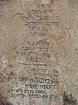
Burial place of Rabbi Moshe Biederman of Lelov inYerushalayim

[The Rebbe of Ruzhin said that if the Jews in Poland were wise, they wouldn’t have permitted such a great Rebbe to depart from them. He provided an allusion to this from a Mishnah in Shabbos, “Ain polin l’ohr haNer"/Do not distinguish by the light of the [Shabbat] candle, which he rendered homiletically as, “The Polish (Jews aren't wise; they had but) let leave their one brilliant light."
When Rebbe Moshe was on the boat, he kept repeating, "yom leshanah” - a day for a year." People didn’t understand his intention. Later they realized that he was praying to live one day for each year of his life. He was seventy-four years old then, and he lived in The Land a corresponding seventy-four days.
Many wondrous stories are told about his voyage. One is that there was a hole in the boat and water began to seep in! Rebbe Moshe placed a cloth over the hole, and this miraculously stopped the influx of water. (This cloth is still extant, and is used as a bedecken tichel (wedding veil) by the kallahs (brides) of his descendants.)
Rebbe Moshe took with him his son Rav Eliezer-Menachem-Mendel (Rav Luzer Mendel), and his six-year-old grandson David-Tzvi-Shlomo (Reb Dovid’l). The ship docked in the northern port of Acco. Rebbe Moshe travelled [by donkey!] to visit the tzaddikim who lived in Tsfat and Teveriya (Safed and Tiberias) and other holy burial sites in the area before going up to Yerushalayim (Jerusalem), because he said that after he gets to Yerushalayim, he will not want to leave.
When he finally came to the Old-city of Jerusalem, he was ill. His children debated whether they should bring him to the Kotel in this condition. They decided that since his primary purpose for coming to Israel was to go to the Kotel to hasten bringing Moshiach, they should. But as they were bringing him towards the Kotel, Arabs blocked their way and threw rocks at them until it was impossible to continue. The family and the chasidim who accompanied them sadly returned to their rented lodgings.
Unfortunately, he never reached the Kotel. [Broken hearted, feeling that the window of opportunity for Redemption had now been slammed shut, he became extremely ill and passed away three days later.] On the seventy-fourth day of his arrival to the Holy Land, on the thirteenth of the Jewish month of Tevet, his soul departed from its bodily restraints.
He promised amazing things about his yahrtzeit. He said that the date of his demise is propitious for rain, and therefore even in a year that is lacking rain, it is unnecessary to proclaim a fast day to pray intensely for rain before his yahrtzeit passes. Rav Shmuel Salant, the chief rabbi of Jerusalem heeded his words, and for the next half century until his own passing refused to decree a fast day for rains until the thirteenth of Tevet passed.
R. Moshe also said that those who will dedicate a meal on his yahrtzeit in his honor (even if it is just cake and l’chaim,) will have a salvation for whatever they need.

Editor’s note: Others will be reported in a future mailing.
Source: Adapted and supplemented by Yerachmiel Tilles from Torah Wellsprings (gleanings from the teachings of Rabbi Elimelech Biderman of Jerusalem -Vayechi 5777), as translated by R. Baruch Twersky. Square-bracketed [ ] insertions are from //littmann613.blogspot.com/2012/08/the-dynasty-of-lelov.html.
Biographical notes Rabbi Moshe Biederman of Lelov [(1776) - 13 Tevet 5611 (1851)] was the son of R. David, the first Rebbe of Lelov, and the son-in-law of "the Holy Yid " of Peshisacha (having married his daughter, Rivka-Rachel). Although he declined to officially succeed his father, considering himself unworthy of the position, the chasidim nevertheless accepted and followed him as Rebbe over his protests.
In 1850, he moved to Israel, and settled in Jerusalem, where he passed away 2 ½ months after his arrival. He was succeeded by his son, R. Eliezer Menachem Mendel, and after him by his grandson, R. David Tzvi Shlomo. The three are buried on the Mount of Olives, near the prophet Zacharia, although the exact location of R. Moshe’s grave is not known
Connection: Seasonal - This Friday, Tevet 13, is the 171st yahrzeit of Rabbi Moshe Lelover.

Reprinted from the Parashat Vayechi 5780 email of KabbalaOnline.org, a project of Ascent of Safed.

Discovering the Engraved Name of Hashem in the
Ravines Near Yerushalayim

Rav Moshe relates:
About 15 years ago there were those that claimed that in the mountains close to Yerushalayim near the Yishuv Beit El there is a special and rare natural phenomenon. Namely, that in the Wadis (ravines) and the mountains in that vicinity is engraved the name of HaShem. (Yud Kay Vov Kay).
Meaning that the ravines split and spread out in a way that forms the name of Hashem. The same people claimed that this is the place where the ladder of Yaakov Avinu was (see Parshas Vayetze and the Gemorro in Chulin, Daf 91-brought in Rashi on the Chumash.)
Hashem Yisborach left a remembrance here in this world as a reminder of the revelation, they claim. They attributed this to the pesukim in Veyzte-Vehinei Hashem Nitzav Alav-And behold Hashem was standing upon him- “chen Yesh Hashem Bamakom Hazeh-Indeed there rests the presence of Hashem in this place.”
Still there was no solid proof of this except for an amateur picture of the mountains which was a clear forgery. It was clear that someone etched out the name of Hashem either with his handwriting or with the help of a computer, to put it in this picture.
People brought these theories before Rav Steinman, ztz”l, asked him if what these people are claiming can possibly be true and they showed him the picture. Rav Steinman ignored any proofs that were mentioned, and he made away with the forged picture entirely.

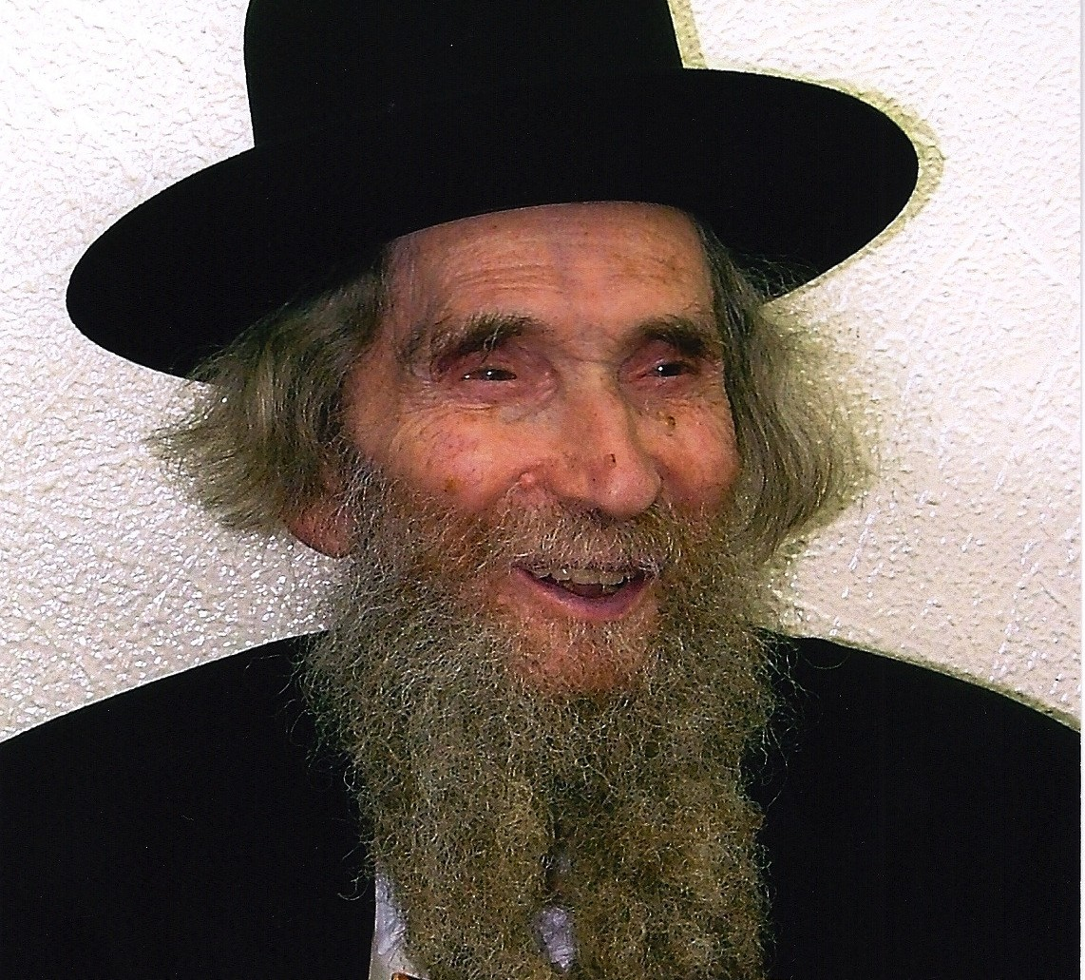
Rabbi Aharon Yehuda Leib Shteinman

But he did say that despite everything, indeed such a phenomenon probably exits, and the name of Hashem can be found by the formation of the mountains and ravines in that area.
The students of Rav Steinman in their experience knew that every word Rav Steinman would say was measured and that he did not speak words for no reason. They decided to investigate this issue further.
It was not possible to go to this area as it is entirely populated by Arabs and going there would be too dangerous.
The students therefore decided to start inquiring from people they knew that may have any relevant information.
They asked numerous pilots, that had done teshuva and become religious, if when they flew over that area, they noticed the name of Hashem. One after the other responded in the negative, and although they agreed that they may not have been paying that much attention, they concluded that as far as they were concerned, they never came across such a phenomenon.
They successfully contacted helicopter pilots but received the same answer. They reached people that were involved in creating maps and satellite pictures but they, as well, never heard of such a thing.
Still they did not give up and they said that if Rav Steinman said that there is such a thing, Hashem will help us to find it.
One day one of these students was sharing the above with an esteemed avreich in Kolel Nachalas Moshe and he told him what he was looking for. The avreich told him that he will ask his wife and get back to him the following day. The student wondered what this avreich’s wife had to do with anything and he explained that his wife works in a high security area containing a secret factory that manufactures missiles for the State of Israel. “Maybe she knows something” he said.
The next morning, he returned to the student of Rav Steinman and said, “Indeed, I found it”.
At the entrance to the factory is a giant picture of Israel which measures 2 times 6 meters, not as a secret document, rather to decorate the building with a beautiful view. There in that picture one can clearly see the name of Hashem formed in the mountains and ravines.
The students rejoiced at the special Hashgocho Pratis, that they came across this avreich, still the quest was not over as they were not permitted to enter this high security top secret factory, nor was anyone permitted to take pictures of it.
They strengthened themselves in Emunah and Bitachon and said that if Hashem helped us to get this far, to discover that which even the experts did not know of, He will certainly help us to complete the task and find the missing information.
And that is what happened.

Bringing the Special Photo to Rav Steinman
After a while, a young man, whose father served in the army and was now released, mentioned, that his father received the above mentioned picture as a gift. It was 6 times 2 meters and was divided into 3 to 4 parts. He related what his father said that indeed one can clearly see there the name of Hashem in that area and he agreed to bring the picture before Rav Steinman.
When the students received the picture, the first thing they did was to approach all the experts they had previously been in touch with and show them the name of Hashem that clearly appeared in the picture.
They were amazed, still the students wanted to know why they did not know about this phenomenon and why this picture taken by satellite is different.
After looking into the matter carefully each of the experts responded with a similar response.
They explained that usually when pictures are taken by air or by satellite, they are careful to take them at midday when the sun is in the middle of the sky so that the shadow from the mountains would not impair the picture.
However, that particular picture, which was taken from a height of 930 kilometers, was taken at an unusual time, early in the morning. Because it was taken at an early hour the shadows were evident upon the nearby ravines and mountains and through this the name of Hashem became apparent.
Each letter of Hashem’s name that was there measured a meter square, such, that the entire name of Hashem was 4 meters wide by one meter long.
The ravines that form the name of Hashem have been there for thousands of years but were never revealed because there were no airplanes helicopters or satellites that could take pictures from above. More than that, even after the time that pictures were being taken, the pictures were not taken in a way that would reveal the above secret.
Only Rav Steinman, with the gift of Sod Hashem Liyeraiav, -Hashem reveals His secrets to those that fear him, knew that this was probable.
When they told Rav Steinman that they came across the picture he expressed his wishes to see it.

Spreading Out the Picture on the Rav’s Round Table
After Rav Steinman’s Chumash shiur, which then ended at 3:30 P.M.) a few students remained and spread out the giant picture on Rav Steinman’s round table, piece by piece from North to South.
Rav Steinman inquired as to where were the mountains of Amnon were, where the miracles of the Yam occurred, where was Kaploria, and other such things that are mentioned in the Gemorra Gitin (Daf 8 amud alef).
After that they placed before Rav Steinman the piece of the map containing the central part of Israel.
After that Rav Steinman wanted to check where Benei Brak was where Yerushalayim was and where the letters of Hashem were on the map.
Later, a number of young children were brought there who fulfill the criteria of being not wise yet not foolish (as per Shulchan Aruch Orach Chaim Siman 32). They were asked to look at the entire map and to see if they could discern any letters, and if so, what these letters were.
Indeed, they were able to discover and identify the name of Hashem from among all the various places on the giant map.
After Rav Steinman was satisfied with determining the name of Hashem he continued looking at the map to find Yam Hamelach (The Dead Sea) Be’er Sheva, Nachal Miztrayim, Midbar Sinai and more.
(Mizkeinim Esbonan, Emunah Ubitachon Shaar cited in the newsletter Sheal Avicha Veyagedcha Parshas Vayetze 5779 by the Dirshu Newsletter 3 Kislev 5780).

Reprinted from a recent email of Rav Dov Brezek’s Shehakol Niheye Bidvaro.

